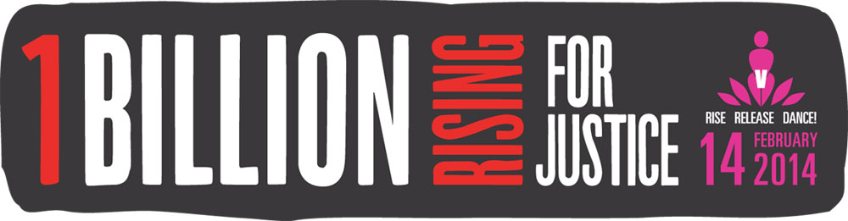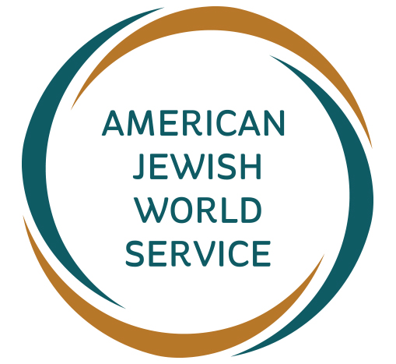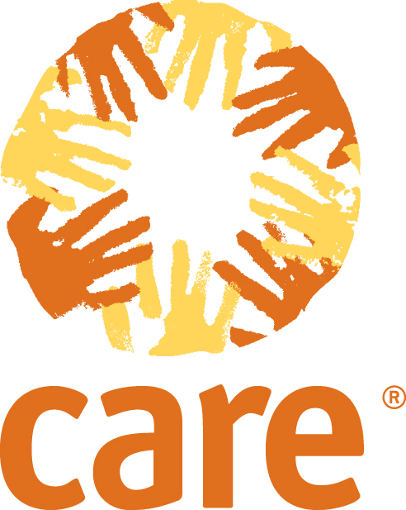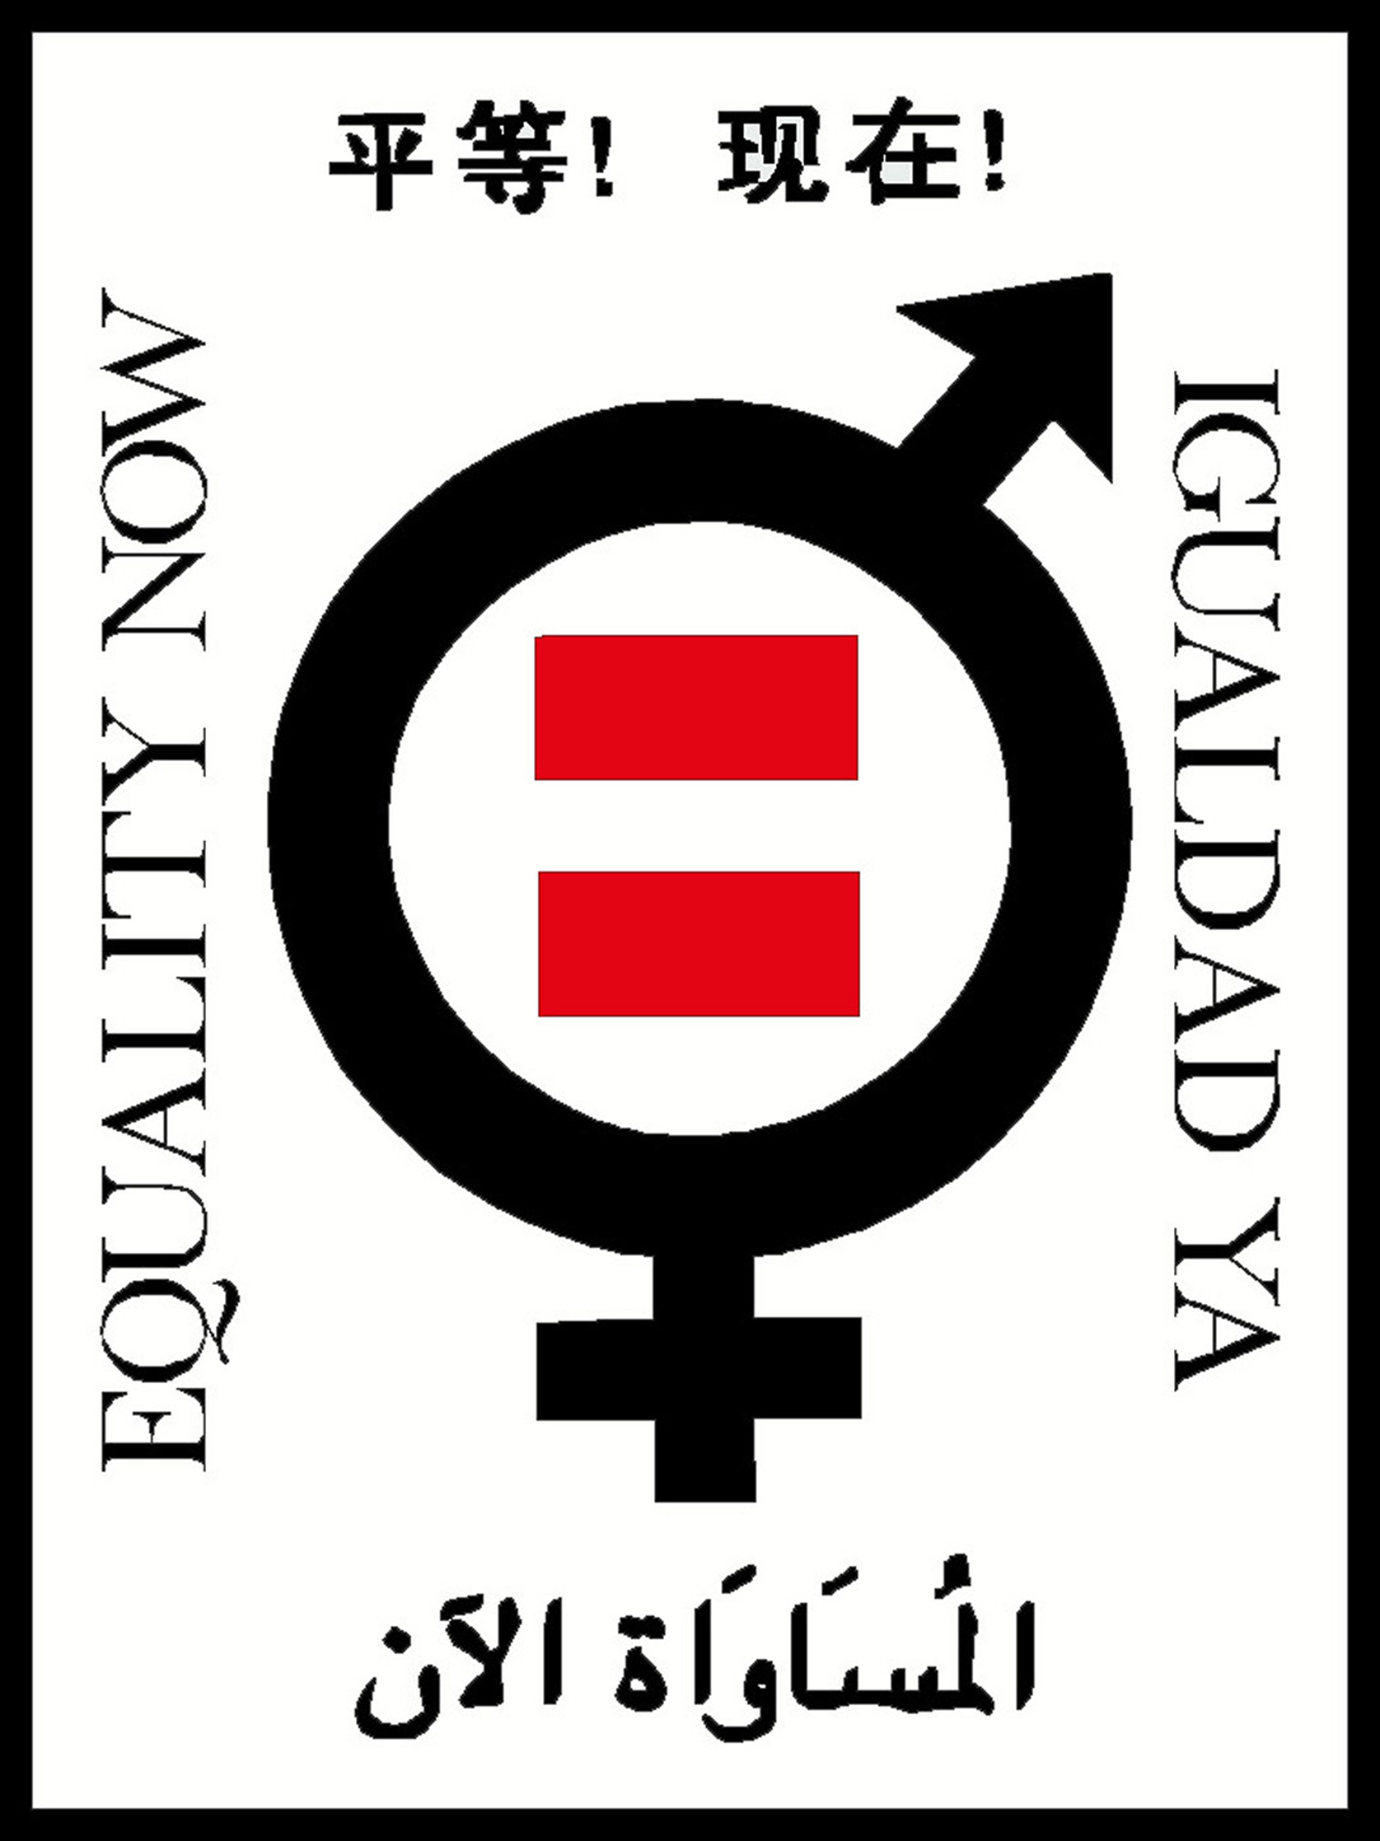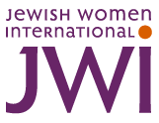
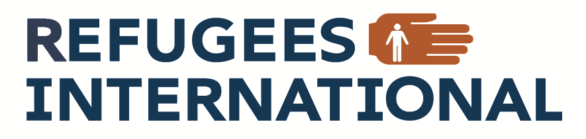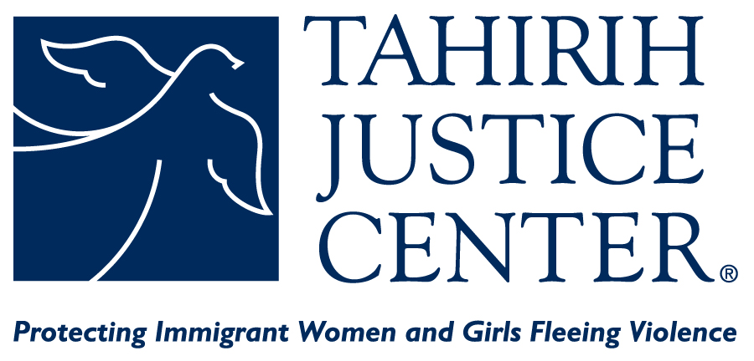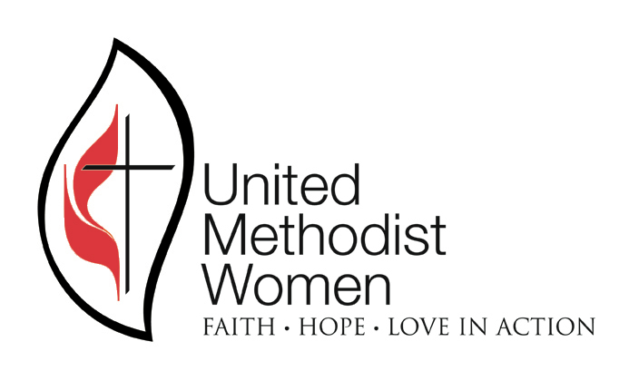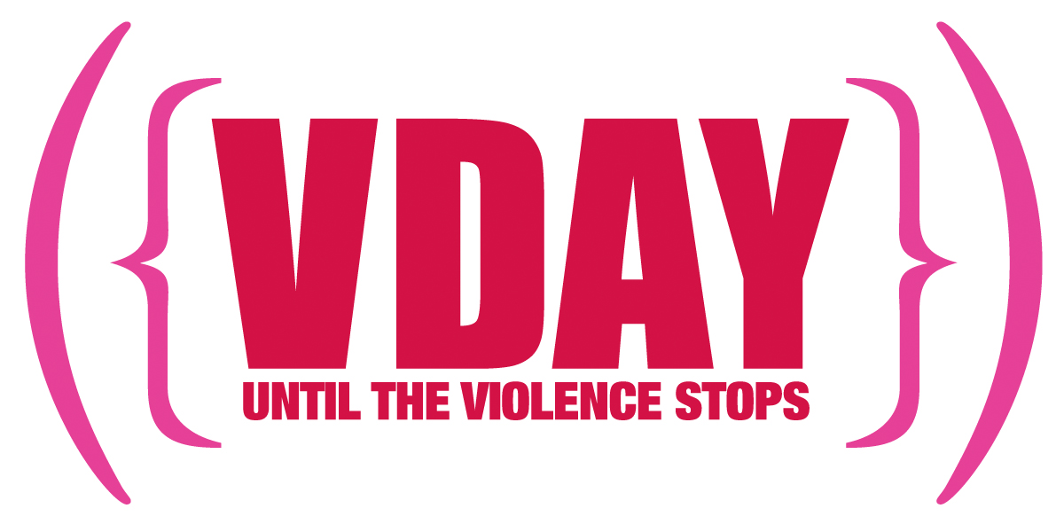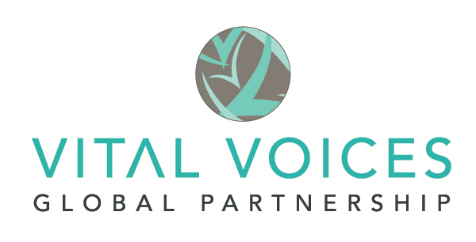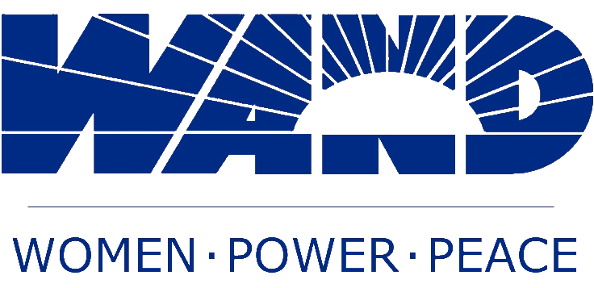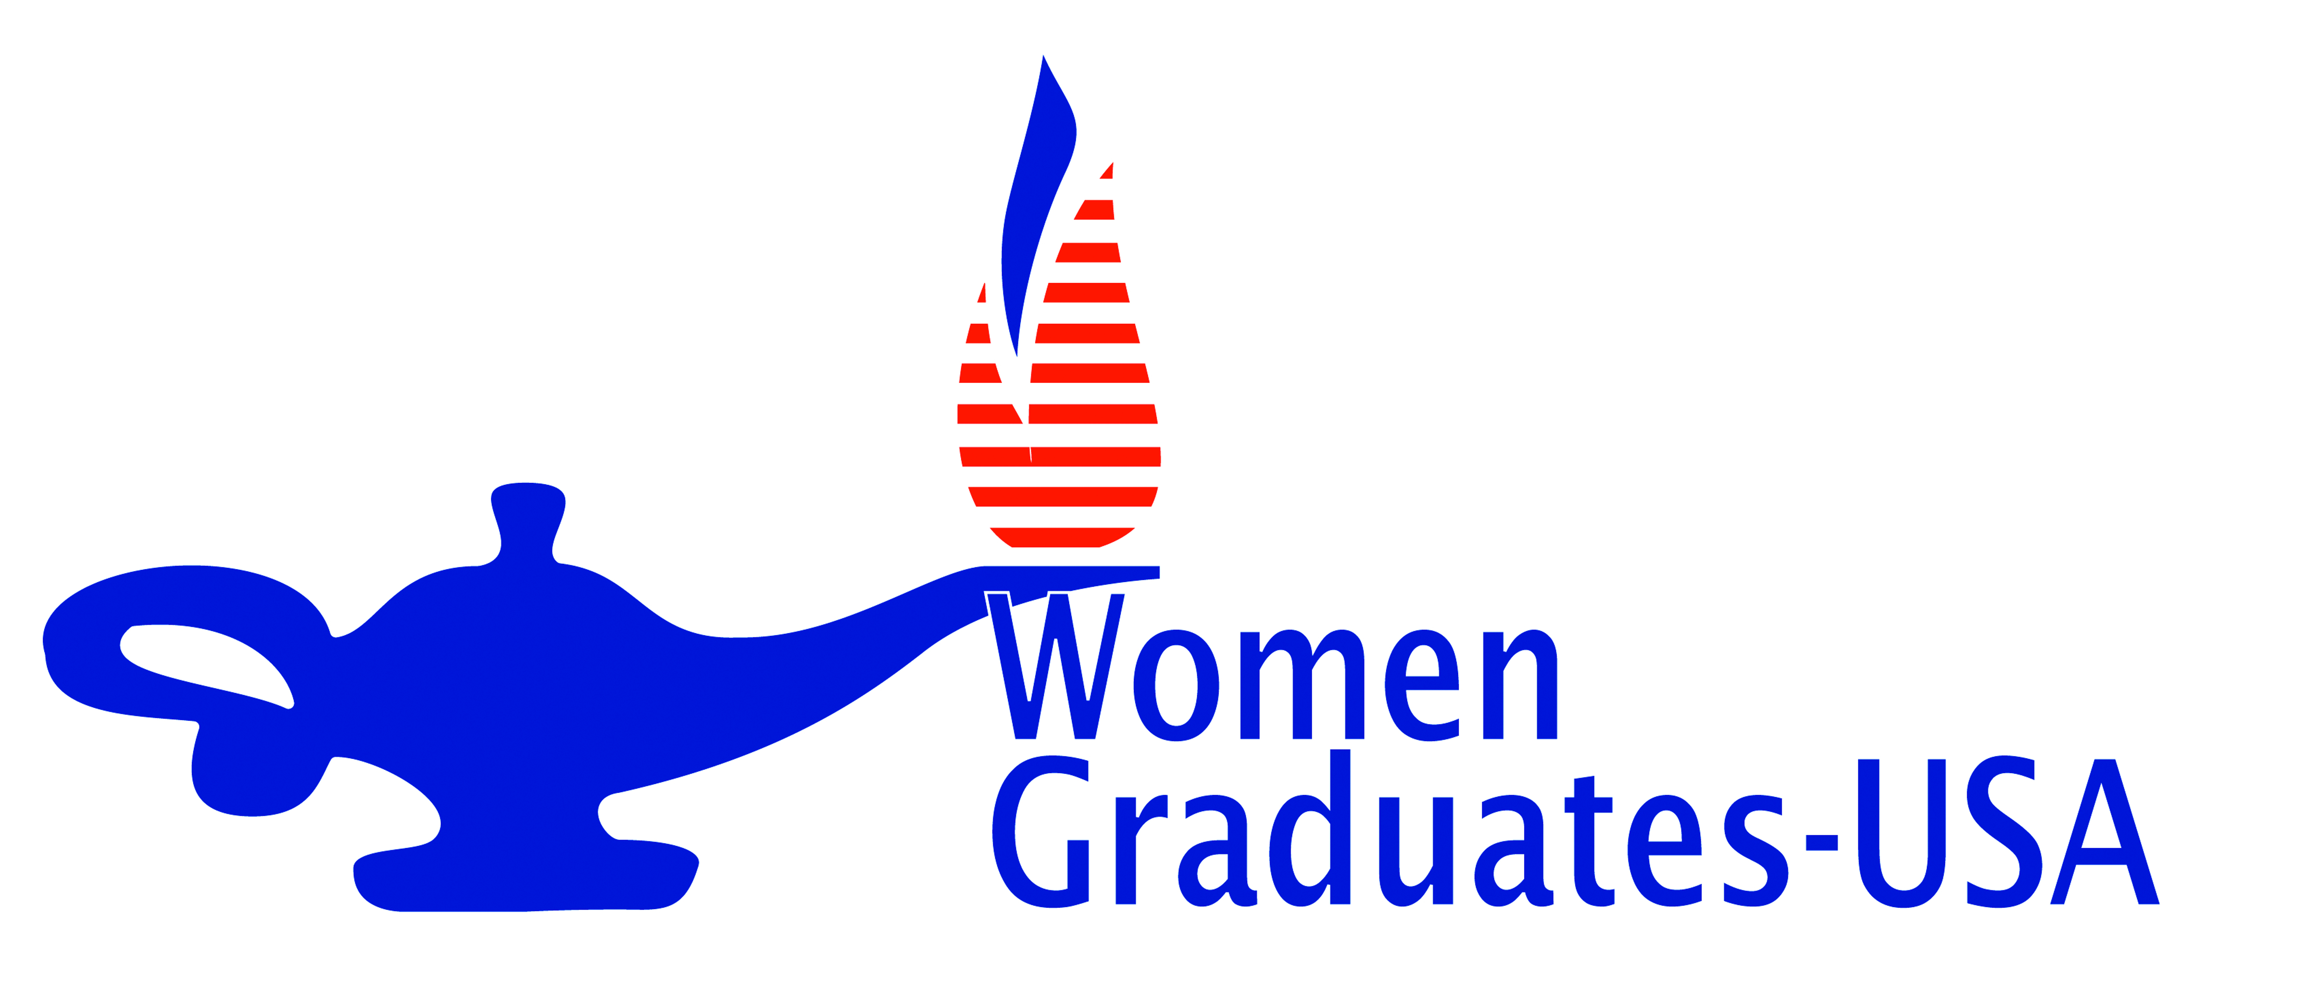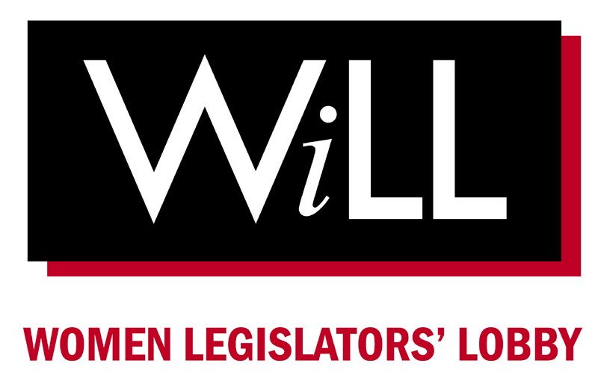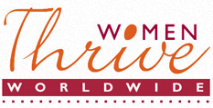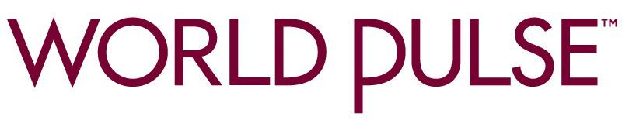

The International Violence Against Women Act
(I-VAWA)

Action Toolkit
Coalition to End Violence Against Women and Girls Globally

2013-2014

Table of Contents

1) Background on I-VAWA page 3

2) Frequently Asked Questions page 5

3) Take Action for I-VAWA
-Online actions page 7
-Send an email action to your networks page 8
-Social media strategy page 9
-Making calls to your Members of Congress page 10
-Sample cosponsor letter to Members of Congress page 11
-Sample thank you letter to Members of Congress page 12
-Sample blog post page 13
-Sample opinion editorial page 14
-Sample letter to the editor page 15
4) Thank You for Taking Action for I-VAWA! page 16

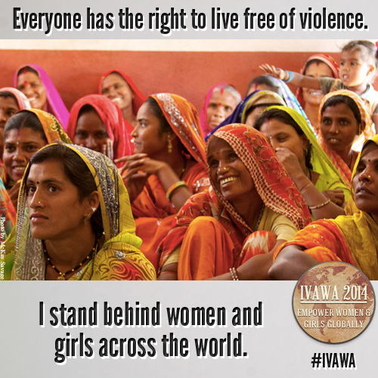

Background on I-VAWA 2013

An estimated one out of every three women worldwide will be physically, sexually or otherwise abused during her lifetime—with rates reaching 70 percent in some countries. Violence against women and girls includes harmful practices that range from rape to domestic violence, to acid burnings and dowry deaths, and so-called “honor killings.” Violence against women and girls is a human rights violation, a public health epidemic and a barrier to solving global challenges such as extreme poverty, HIV/AIDS and violent conflict. It devastates the lives of millions of women and girls—in peacetime and in conflict—and knows no national or cultural barriers. Most importantly, it must end.

In August of 2012, the U.S. government released its first ever U.S. Strategy to Prevent and Respond to Gender Based Violence (Strategy). The Strategy is largely derived from and has long been a core component of the International Violence Against Women Act (I-VAWA) and its release is a historic and unprecedented effort by the United States to address violence against women and girls globally.

In 2013-2014, the I-VAWA will direct the U.S. government to implement its Strategy to reduce violence against women and girls in at least five countries where it is severe. Enhanced data collection and transparency of results is a core component of the bill that ensures accountability and the continued use of best practices. The I-VAWA recognizes that violence intersects with nearly every facet of women’s lives and therefore supports health programs and survivor services, encourages legal accountability and a change of public attitudes, promotes access to economic opportunity projects and education, and addresses violence against women and girls in humanitarian situations. The I-VAWA also emphasizes support and capacity-building for local women’s organizations already working to stop violence against women and girls.

The I-VAWA makes ending violence against women and girls a top diplomatic priority. It permanently authorizes the Office of Global Women’s Issues in the State Department as well as the position of the Ambassador-at-Large for Global Women’s Issues, who is responsible for coordinating activities, policies, programs, and funding relating to gender integration and women’s empowerment internationally, this includes those intended to prevent and respond to violence against women and girls.

More specifically, the I-VAWA would do the following:

Increase Legal and Judicial Protection to Address Violence Against Women and Girls.
The I-VAWA focuses on establishing and supporting laws and legal structures that help prevent and appropriately respond to all forms of violence against women and girls. Emphasis is placed on promoting political, legal, and institutional reforms that recognize violence against women and girls as a crime and train police and the judiciary to hold violators accountable and to respond to the needs of victims. This includes helping women and girls access the justice sector and ensuring that they are safe and supported throughout the legal process.

Increase Health Sector Capacity to Address Violence Against Women and Girls.
The I-VAWA will integrate programs to address violence against women and girls into already existing health programs focused on child survival, women’s health, and HIV/AIDS prevention, care, and treatment. It takes a holistic “systems” approach and emphasizes enhancing the capacity of the health sector to assess the impact of violence on a woman and girl’s health and help her protect herself from violence.

Change Social Norms to End Violence Against Women and Girls.
The I-VAWA focuses on preventing violence by changing community norms and attitudes about the acceptability of violence against women and girls. It will support public awareness programs to change attitudes that condone and at times encourage violence against women and girls, and will emphasize community-based solutions. For instance, activities supported by the I-VAWA could include programs that organize women and girls who are survivors of violence to speak out publicly or work with male leaders to help other men and boys become more supportive of respectful and non-violent relationships.

Increase Women’s Economic Opportunity and Education.
The I-VAWA focuses on reducing women and girls’ vulnerability to violence by improving their economic status and educational opportunities. Emphasis is placed on ensuring women’s access to job training and employment opportunities and increasing their right to own land and property. This would allow them to potentially support themselves and their children. The legislation also addresses the rights of women and girls to work and go to school free of sexual coercion and assault.

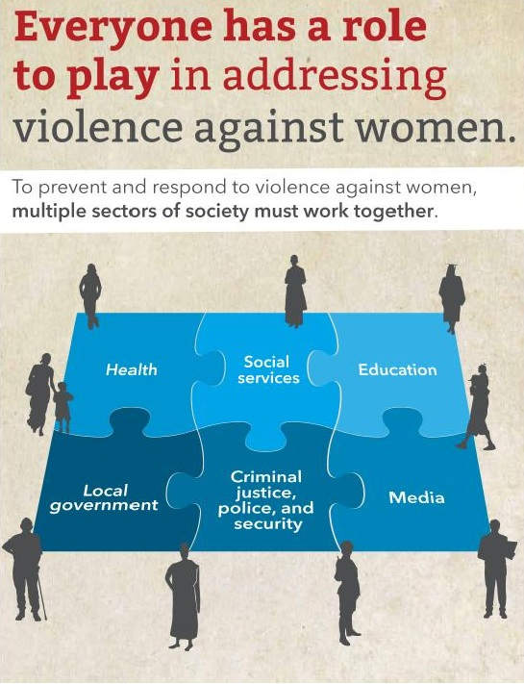
World Health Organization

Frequently Asked Questions

1. What is the International Violence Against Women Act?

The International Violence Against Women Act (I-VAWA) is a piece of legislation that was introduced in the 110th, 111th, 112th, and now in the 113th Congress that represents an unprecedented commitment by the United States Government (USG) to prevent and respond to violence against women and girls globally. It would, for the first time, codify a comprehensive approach by the U.S. to fight violence against women and girls internationally. I-VAWA directs the USG to create and implement a comprehensive, multi-sectoral 5-year strategy (such as the U.S. Strategy to Prevent and Respond to Gender-based Violence Globally) to reduce violence in at least five low- to middle-income countries that have severe levels of violence against women and girls.
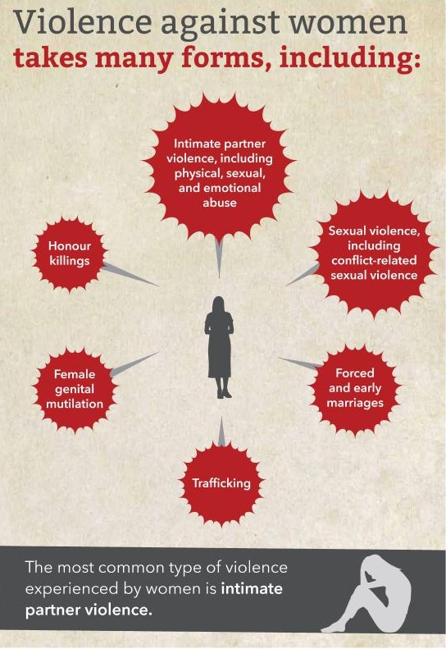
2. What exactly do you mean by violence against women and girls?

The United Nations Secretary General defines violence against women and girls as: “any act of gender-based violence against women or girls committed because of their gender that results in, or is likely to result in, physical, sexual, or psychological harm or suffering to women, including threats of such acts, coercion, or arbitrary deprivations of liberty, whether occurring in public or private life.” This means that the violence could occur in the family (battering, sexual abuse of female children in the household, dowry-related violence), within the general community (rape, sexual abuse in school or at work, forced prostitution, female genital mutilation/cutting and other traditional practices harmful to women), or it could be perpetrated or condoned by state agents.

3. Is violence against women and girls a major problem?

Violence against women is a worldwide human rights violation and a public health epidemic that knows no cultural, national or ethnic boundaries. The UN Development Fund for Women estimates that an estimated one out of every three women in the world will be beaten, coerced into sex, or otherwise abused in her lifetime. In some countries, close to 70 percent of women report such violence. One World Health Organization
billion women and girls are affected by such violence, including rape, domestic violence, acid burning, dowry deaths, so-called honor killings, human trafficking, female genital mutilation/cutting and other harmful practices. In times of conflict mass rape is often used as a weapon of war.

4. How was the I-VAWA created?

The I-VAWA was initiated by a coalition of non-governmental organizations led by Futures Without Violence, Women Thrive Worldwide and Amnesty International USA, in 2005 to increase USG efforts to prevent and respond to violence against women and girls internationally. It is the result of extensive research on what works: it was drafted in consultation with more than 150 groups including U.S.-based NGOs and 40 women’s groups across the globe. In 2007 the coalition consulted with Vice President (then Senator) Joseph Biden (D-DE), Senator Richard Lugar (R-IN) and Representative Howard Berman (D-CA) who originally introduced the legislation in the 110th Congress.

5. How will passing this legislation help women?
In many cases local women’s organizations who have been working for years to assist women and girls affected by violence in their countries will finally get the help they deserve. Programmatic support and capacity building will focus on both prevention, such as economic opportunity programs and public education campaigns to change attitudes, and intervention, such as health care for women who have been raped and who may become infected with HIV/AIDS. Women and girls globally will also benefit from increased U.S. and world diplomatic attention as the problem of violence against women and girls moves from an invisible private suffering to a public issue that governments work to solve.

6. What about men and boys?

The legislation in no way prevents help or support from going to end violence against men and boys. Rather, the I-VAWA recognizes the desperate inequality that is still experienced by most of the world’s women and girls and the violence that contributes to and results from that inequality. In much of the world, women and girls may still be raped and beaten with impunity and can be sold or given away to men. They can be killed for disobedience or appearing in public with a man who is not a relative or simply for being born a girl. Many cannot vote, own property or have any rights to their own children. It is this extreme level of violence and abuse women and girls experience simply because of their gender that the legislation seeks to address. Furthermore, the bill cites engaging men and boys as a key programmatic area to prevent gender-based violence. Men and boys should be seen as allies and not enemies.

7. How will I-VAWA affect U.S. foreign policy?

For the first time, U.S. diplomatic work will address this problem in a coordinated, integrated way. In August of 2012, President Barack Obama released the U.S. Strategy to Prevent and Respond to Gender-Based Violence Globally via an Executive Order. The Strategy was largely modeled after the comprehensive approach outlined in I-VAWA. I-VAWA now seeks to codify the Strategy, to ensure effective and efficient programming, accountability, as well as monitoring and evaluation of gender-based violence initiatives.

8. Isn’t this the United States trying to impose its culture on other nations?

The I-VAWA does not try to impose the cultural morals of the United States on other countries; rather, it seeks to support the work of local Indigenous women and communities who have long been advocating for an end to the violence and abuse experienced by women and girls. In addition, it recognizes that much of U.S. efforts to help countries address problems such as HIV/AIDS, maternal mortality, poverty and conflict are aided by addressing violence against women and girls. In fact, these other efforts will only be successful if concurrent efforts to support women’s education and empowerment are also taking place.

9. What is the difference between I-VAWA and the Violence Against Women Act (VAWA)?

The Violence Against Women Act (VAWA) is a domestic criminal justice and social services law that addresses violence against women within the United States. The I-VAWA is a piece of pending legislation to address violence against women and girls around the world by requiring that U.S. government agencies that engage in foreign assistance work overseas take all possible steps in their programming to prevent and respond to gender-based violence and to be coordinated in these efforts. While both bills focus on preventing violence, supporting survivors and bringing perpetrators to justice, the way they go about achieving those aims are very different.

10. How is violence against women and girls related to human trafficking?

Trafficking of persons is a global human rights problem. Victims are trafficked into a range of forced labor situations including farm work, sweatshops, domestic servitude, and sexual exploitation. Violence against women and girls is one of the underlying issues that contribute to people’s vulnerability to being trafficked, and many women face violence as they are trafficked. However, many victims of human trafficking are men and boys trafficked for forced labor, so trafficking is distinct from violence against women and girls. In addition, the United States already has legislation to address human trafficking. The Trafficking Victims Protect Act was passed in 2000 and has been reauthorized since then to combat all forms of human trafficking.
Take Action for I-VAWA!

Building awareness about the I-VAWA’s introduction is critical to building significant Congressional support and ultimately to the bill’s passage, as well as overall public education on violence against women and girls globally.
Below is a list of online actions links from organizations in the Coalition to End Violence Against Women and Girls Globally that you can click to take action for the I-VAWA.
Please take action and share the below links to your networks via email and through social media. Sample email text and social media posts are on the following pages. And of course, feel free to utilize any of the messaging to create your own online action!
www.aiusa.org/ivawa
www.futureswithoutviolence.org/section/ivawa
www.womenthrive.org/ivawa-thanks

Note: To find out who your member of Congress is, go to http://www.congress.org/congressorg/dbq/officials/

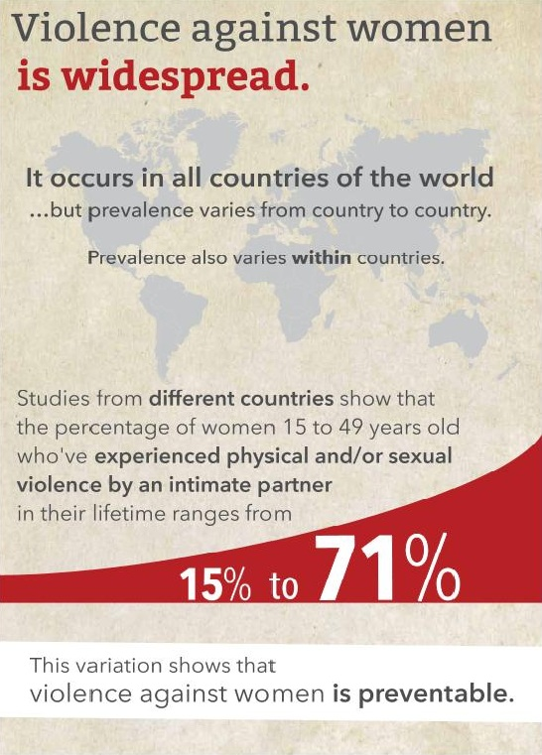
World Health Organization

Send an Email Action to Your Lists

From: [YOUR ORGANIZATION’S SIGNER], [YOUR ORGANIZATION]
Subject: [YOUR ORGANIZATION’S SUBJECT LINE]
Dear [firstname],
Exciting news!
U.S. Representative Jan Schakowsky has just re-introduced the International Violence Against Women Act (I-VAWA) and Senate action is anticipated in the coming weeks! I-VAWA is legislation that will support on-the-ground efforts around the world to reduce violence against women and girls.
Please take a moment to ask your Members of Congress to support this important bill [insert online action link].
The numbers are staggering:
- Upwards of 70 percent of women in some countries will experience violence in their lifetimes.
- Each year, around 3 million girls and women—or some 8,000 girls each day—face the risk of female genital mutilation or cutting. An estimated 130 million to 140 million girls and women have already undergone the practice.
- In some countries, as many as 30 percent of women report that their first sexual experience was coerced or forced. The younger a woman was at the time of sexual initiation, the higher the chance that it was violent.

Fortunately, you and I can help make the world safer for women and girls.
The International Violence Against Women Act would provide essential support for proven strategies to prevent and respond to violence against women and girls. And it would bolster the efforts of women and men around the world who are working to reduce gender-based violence in their communities.
Take action now [insert online action link] and help support passage of the International Violence Against Women Act.
Gender-based violence is a global problem, but you and I can play a special role in making the world a safer place for women and girls. Please take action now.
With Gratitude,

[YOUR ORGANIZATION’S SIGNER]

Social Media Strategy
Below are some guidelines and sample messages for Facebook and Twitter. Please feel free to change according to your own issues and audience: Individualized messages do work better.
To accompany your social media content, you are welcome to use the I-VAWA graphic to the right. The graphic can be downloaded here: http:bit.ly/190tQrG.

Facebook:
Sample FB posts (to post on organizational or personal pages):

- Violence devastates the lives of millions of women and girls—in peacetime and in conflict—and knows no national or cultural barriers. [I’m / We’re] encouraging Members of Congress to cosponsor and support the International Violence Against Women Act, join [us / me]! [ATTACH I-VAWA GRAPHIC]
- Do your Senators and Representative support the International Violence Against Women Act? Join [me / us] in showing your support by sending your representatives a message on their Facebook page, urging them to support women and girls across the world! [ATTACH I-VAWA GRAPHIC]

Sample FB message (to post on Congressperson’s page):

- Worldwide, millions of women and girls are subject to violence simply because of their gender. This is not only a gross violation of human rights, but is a threat to global health and economies around the world. Cosponsor and support the International Violence Against Women Act (IVAWA) today! [ATTACH I-VAWA GRAPHIC]
- Living free from violence is a human right. Please support the International Violence Against Women Act (IVAWA) [ATTACH I-VAWA GRAPHIC]
- The time is now to end violence against women and girls globally. Please be a leader in this movement and cosponsor the International Violence Against Women Act (IVAWA) [ATTACH I-VAWA GRAPHIC]

Twitter: Please use the hashtag #IVAWA.
Sample Twitter messages:

- The time is now to end #GBV! Encourage your Reps to support women and girls across the globe with #IVAWA! [link to online action]
- Pls RT! Everyone deserves a life free of #violence. Tell Congress to act now and support #IVAWA [link to online action]
- Protect ALL women and girls from #violence! @[INSERT SENATOR/REP] support #IVAWA today: http://bit.ly/11XnwlM #WomensRights
- .@[INSERT SENATOR/REP] I support the rights of women and girls globally, do you? Support #IVAWA today: [link to online action]
- Thanks to @[INSERT SENATOR/REP] for [his/her] leadership and hard work to end #genderbasedviolence. #IVAWA
- Worldwide, 15-71% of women aged 15- 49 reported physical/sexual violence by an intimate partner at some pt in their lives. #IVAWA
- An estimated 5,000 adolescent girls and women are killed by family members in the name of honor every year. Support #IVAWA! Pls RT.
- Women and girls who experience #genderbasedviolence can be agents of change with support. #IVAWA

Making Calls to Your Members of Congress

Please use the below sample scripts to call your Senators and your Representative and ask them to cosponsor I-VAWA today!
You can reach the Capitol Switchboard at 202.224.3121
- Telephone calls are usually taken by a staff member. Ask to speak with the aide who handles women’s issues or foreign affairs issues.
- After identifying yourself as a constituent, tell the staffer that you would like to leave a brief message.
“Please tell Representative/Senator ____________ that I support the International Violence Against Women Act.”
- Ask for the position of your Member of Congress on the bill. If they are a co-sponsor, thank them for their support and urge them to help pass IVAWA in 2013.
- If they are not a cosponsor, you can say:
“Please urge the Representative/Senator ____________ to cosponsor the bill and help pass IVAWA in 2013.”
- And add:
“I support the bill because:
- Violence against women and girls is a human rights violation occurring globally.
- An estimated one in every three women globally has been beaten, coerced into sex, or otherwise abused in her lifetime.
- The International Violence Against Women Act supports measures to prevent violence, protect survivors and bring perpetrators to justice.
You can and should request a written response to your telephone call.

Sample Letter to Members of Congress: Please Cosponsor I-VAWA

Please feel free to utilize the following sample letters to Members of Congress, blog post, opinion editorial and letter to the editor as-written OR use the text as examples to craft your own individualized versions that fit your issues and audience.

Sample Letter to Members of Congress (Cosponsor I-VAWA)
The Honorable [First Name] [Last Name]______________
[Insert the Office Address of your Member of Congress here – find it at http://www.usa.gov/Contact/Elected.shtml]
Dear Senator/Representative [last name],
I am writing to urge you to co-sponsor the International Violence Against Women Act (I-VAWA) in 2013.
The widespread prevalence of gender-based violence around the globe is atrocious. Rates of violence reach up to 70 percent in some countries. Every day, women and girls around the world are forced to trade sex for food or school fees. Every day, women and girls are beaten and abused. The list goes on and on.

Adding insult to injury, all too often these violent crimes are not prosecuted and, worse still, they become socially accepted and tolerated. Violence against women is a global health crisis and human rights violation that contributes to instability and insecurity throughout our world.

The American public is behind ending violence against women. A 2009 poll found that 61 percent of voters across demographic and political lines thought global violence against women should be one of the top international priorities for the U.S. government, and 82 percent supported the I-VAWA.

I am asking you, Senator/Representative [LAST NAME], to stand up for women and girls and help pass the International Violence Against Women Act.

This bill supports innovative, cost-effective programs that have been shown to decrease acts of violence. Many of these programs help women and girls do things we so often take for granted: go to school, earn an income to help sustain families, collect food or water without fear of rape or harassment, and bring perpetrators of abuse to justice. The I-VAWA will also streamline and improve existing U.S. programs to end violence against women -- increasing the efficiency and effectiveness of our international assistance.

The International Violence Against Women Act provides the United States with a critical opportunity to make a real difference. The world’s women and girls need this legislation.

Protecting and empowering women is a moral imperative and just smart foreign policy. Please help change the lives of millions of women and girls by co-sponsoring I-VAWA.

Yours sincerely,
(Your name and address)
**Or ask other group members and constituents to add their names and address to one letter.**

Sample Thank You Letter to Members of Congress

The Honorable [First Name] [Last Name]
[Insert the Office Address of your Member of Congress here – find it at http://www.usa.gov/Contact/Elected.shtml]
Dear Senator/Representative [Last Name],
I am writing to thank you for demonstrating your commitment to ending abuses against women and girls globally by co-sponsoring the International Violence Against Women Act (I-VAWA).

When implemented, this important piece of legislation will help put an end to the fear and suffering experienced by hundreds of millions of women and girls. All too often, gender-based violence goes unaddressed. Crimes regularly are not prosecuted and, worse still, they become socially accepted and tolerated.

Your support for ending gender-based violence worldwide is wonderful. Thank you for taking a stand by co-sponsoring a bill that will show the world that the United States refuses to tolerate violence against women and girls anywhere.

As you know, the International Violence Against Women Act supports innovative, cost effective programs to help victims, hold perpetrators accountable, and prevent violence. We are grateful to you for supporting such a comprehensive piece of legislation that will have a significant impact on ending violence against women and girls globally.

We look forward to your continued support of I-VAWA!

Yours sincerely,
(Your name and address)
**Or ask other group members and constituents to add their names and address to one letter.**

Sample Blog Post
Help Stop Violence Against Women Worldwide
By [Your Name]

Every day, women and girls around the world are subject to physical and sexual violence. Gender-based violence knows no physical or cultural boundaries, occurring in times of war and peace and in every single country around the world. Shockingly, rates are as high as 70% in some countries.

But this is a problem with a solution.

The U.S. government has a critical role to play in preventing and ending gender-based violence worldwide. And Members of Congress have a unique opportunity in this important effort.

Passing the International Violence Against Women Act (I-VAWA) is one of the best ways the U.S. can help. This new bill – introduced by Representative Jan Schakowsky (D-IL) and soon to be introduced in the Senate, represents a crucial step in sticking up for and empowering women and girls worldwide.

The International Violence Against Women Act (I-VAWA) integrates violence prevention and response into U.S. foreign policy and supports proven programs that can reduce violence against women and girls.

On any given day, horrifying news stories about such violence appears across the news:

The systematic rape of women in the Democratic Republic of Congo.

Increasing assaults on the women and girls standing up for their rights in Afghanistan.

Violence against women and girls in Haiti whose lives are already devastated by the earthquake.

Sadly, the list could go on for days. These horrific instances of gender-based violence are not isolated to a few women in a few places- they are just the stories that make headlines.

Incidents of violence against women internationally can seem distant and incomprehensible. But the women affected share many of the same dreams and aspirations as our sisters, our daughters, our friends and lovers, and our neighbors.

Violence takes the lives of millions of women and girls, and denies countless others their dignity and the chance to live safe, productive lives. And, in a world where tensions and violence within communities can jeopardize national and international security, it is vital that the United States take action.

We cannot turn away. We must end atrocities committed against women and girls in their homes and in their communities, during times of peace and times of conflict.

The United States Congress can help address these horrifying abuses. Lawmakers should move quickly to pass IVAWA and signal the United States’ commitment to stopping violence against women and girls worldwide.
You, your family, and your neighbors now can let lawmakers know you want more to be done to address violence against women globally. And you can do it right now.
Let your Member of Congress know that ending violence against women and girls is important to you. Send a message urging him or her to pass the International Violence Against Women Act.
Sample Opinion Editorial

A Great Step Forward to Stop the Epidemic of Violence Against Women and Girls
The International Violence Against Women Act would for the first time place gender-based violence at the center of the U.S. foreign policy and international aid agenda. The Coalition to End Violence Against Women and Girls Globally is pushing Congress to reintroduce and pass this vital legislation in 2013.

Around the world, with sickening frequency we hear about another instance of violence against a girl or woman. A five-year-old is raped in India. A girl is shot in the head in Pakistan on her way to school. Twenty six women are sexually assaulted by police in San Salvador Atenco, Mexico. A women’s rights advocate in Afghanistan is murdered in the street.
Violence against women and girls is one of the world’s most pervasive human rights abuses and a tremendous and costly problem. The United Nations estimates that one in every three women will experience violence at some point in her life with rates reaching up to 70% in some countries. Women and girls fall prey to sex traffickers, are attacked as they attend school, endure brutality in the home, or are raped in conflict zones.
From Afghanistan and Mexico to India and Egypt, violence against women destabilizes families and communities, blocks economic progress, and undermines women’s efforts to create better lives for themselves and their families.
The terrible consequences of this epidemic of violence rob countries of the contributions and talent of half their populations. Violence takes the lives of millions of women and girls, and denies countless others their dignity and their right to live safe, productive lives. No country is immune. Violence crosses all national borders and affects women of all ages, social groups, religions, and economic, racial and ethnic groups.
Consider “Connie” from Nicaragua, whose father physically abused her for years, then started raping her from age nine, sometimes preventing her from going to school. If passed, the International Violence Against Women Act (I-VAWA) would make gender-based violence prevention and response a lens through which U.S. government foreign aid is evaluated with the goal of using aid to respond to and ultimately reduce levels of violence. So, for example, health care providers would be trained to recognize signs of violence and know how to lend support to girls like Connie. It would mean, as another example, that the U.S. Agency for International Development would assist in putting protections in place to ensure that girls can go to school safely. And, it would mean resources to help organizations that are working to change the attitudes of men and boys about violence.
Investing in women makes sense because when women and girls thrive, societies are more likely to prosper, reduce rates of HIV and AIDS, decrease child and maternal mortality, and increase participatory and democratic governments– all of which makes U.S. assistance dollars go farther. U.S. security – and the security of all countries -- is only enhanced when the status of women is elevated. So addressing violence against women is crucial to global development and stability, and by extension, to U.S. security.
Working through the international assistance that the U.S. already provides to countries around the world, this bill will support best practices against violence so that authorities can bring perpetrators to justice and women and girls can go to school, earn an income, and collect food or water without fear of rape.
Last year, the U.S. government took a step to help millions of women and girls by releasing its first ever U.S. Strategy to Prevent and Respond to Gender-Based Violence Globally. This comprehensive strategy improves existing aid programs with the goal of helping to prevent and reduce violence against women. This effort must be sustained through passage of the International Violence Against Women Act. I ask [your Member of Congress] to support the bill and ask [his and her] colleagues to do the same.
Supporting the International Violence Against Women Act is in the United States’ interests as well as being the right thing to do. We must all make our voices heard. Tell lawmakers to do more to stop violence against women and girls across the globe.

Sample Letter to the Editor

To the Editor:

From Afghanistan and Mexico to India and Egypt, violence against women and girls is one of the world’s most pervasive human rights abuses and a tremendous and costly problem: it destabilizes families and communities, blocks economic progress, and impedes one out of three women worldwide from creating better lives for themselves and their families.
Last year, the U.S. government took a key step to support millions of women and girls by releasing its first ever U.S. Strategy to Prevent and Respond to Gender-Based Violence Globally. This comprehensive strategy improves existing foreign assistance programs with the goal of helping to prevent, reduce and ultimately end violence against women.
This effort must be sustained through passage of the International Violence Against Women Act (I-VAWA), a bill that will make existing efforts to stop violence against women more integrated, effective and efficient, placing women at the center of U.S. diplomatic efforts where I believe it belongs.
I ask [your Member of Congress here] to support the bill and ask [his or her] colleagues to do the same.
Violence against women and girls is a pervasive human rights crisis that demands a strong response. I ask [your Member of Congress here] to do just that and support this effort.

Name
Town, State and affiliation

Thank You for Taking Action for I-VAWA!

As members and supporters of the Coalition to End Violence Against Women and Girls Globally, we are committed to ending the global epidemic of violence against women and girls. Through our combined efforts, we have the chance to make a difference for hundreds of millions of women and girls worldwide who are face the threat of violence on a daily basis.
Thank you for your commitment to upholding the right of all women and girls to live free from violence, intimidation and fear. Thank you for all your efforts to push for strong Congressional support and passage of the International Violence Against Women Act.
Every action you take for this critical priority makes a difference and on behalf of the coalition, thank you for your support.
Please feel free to contact the Coalition with any questions, requests for additional information, or to share the outcomes of your advocacy and outreach efforts.

Contact Information:
Julia Drost, Amnesty International USA: 202-675-8758, jdrost@aiusa.org
Celia Richa, Futures Without Violence: 202-595-7387, cricha@futureswithoutviolence.org
Christine Hart, Women Thrive Worldwide: 202-999-4476, chart@womenthrive.org
Ben Weingrod, CARE USA: 202-609-6360, bweingrod@care.org

