China  Why?  What? | Passport  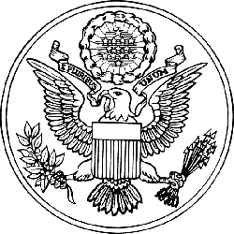  Name: __________________________
Native Americans
Why?

What?

China  Why?  What? | Passport  Name: __________________________
Native Americans
Why?

What?

England  Why?  What? | Africa  Why?  What?
Ireland  Why?  What? | Mexico  Why?  What?

England  Why?  What? | Africa  Why?  What?
Ireland  Why?  What? | Mexico  Why?  What?

