Refugee Relief in Europe, September 2015
How Can FAWCO Clubs Help?
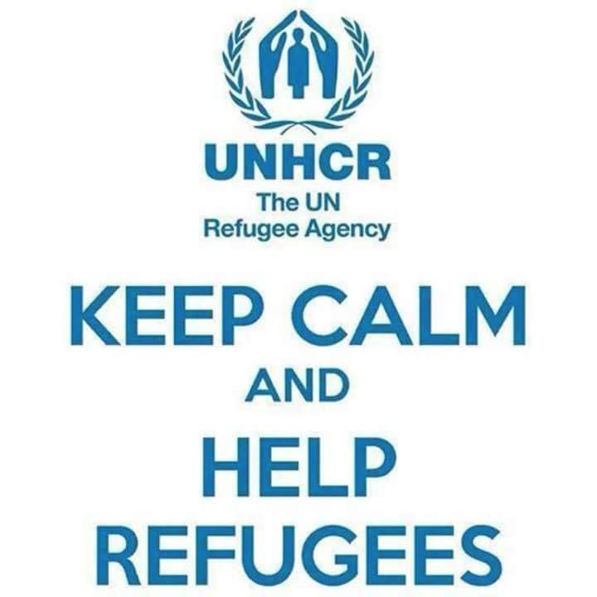
We see the headlines every day, and read articles like this one from the New York Times (Sept. 14, 2015): “More than 200,000 Syrian people have been killed in the 4 1/2-year Syrian civil war.The constant violence has forced more than four million to flee the country, fueling a refugee crisis in the Middle East and Europe...”
FAWCO women are well-informed, so there's no need to recap the news here. However, for background information, this recent BBC article summarizes the ongoing situation with refugees arriving in Europe from Syria, Iraq, Afghanistan, and other countries in conflict: http://www.bbc.co.uk/news/world-middle-east-34224619 FAWCO clubs in Lebanon, Greece and Italy have been especially affected by, but in recent weeks, the influx of people fleeing from war has arrived in Europe.
In September 2015, FAWCO member clubs expressed increasing concerns about the refugee crisis and asked how they could help. We put together these resources about organizations clubs can support on the global level, as well as suggestions for ways clubs can assist with hands-on volunteering or in-kind donations at the local level. If you know of other resources or have more ideas, please send them to UN Liaison Laurie Richardson (AWA Vienna) unliaison@fawco.org.
Background: Since early 2014, FAWCO members support refugees
The FAWCO Human Rights Task Force and the UN NGO Team have been engaged in supporting refugees since March 2014. At the FAWCO International Conference in Brussels, we heard a representative of the UN Refugee Agency (UNHCR), Emily Takehashi, speak about the growing numbers of refugees and the difficulties refugee women and children face in flight and in camps. A group of Region 9 club members came together to get more involved. Therese Hartwell (AWEP), then chair of the Human Rights Task Force Women Peace and Security Committee, travelled to Jordan to learn about the refugee situation there first hand; you can read Therese's blogs to learn about her experiences, and contact Therese directly by email. In December 2014, Region 9's regional meeting in Amman, Jordan connected members with a hands-on opportunity to volunteer with a local community center serving refugees from Syria and Iraq – the Collateral Repair Project (CRP). Region 9 members brought in-kind donations of handcraft and needlework supplies for economic empowerment projects for refugee women, and donated funds to support the expansion of CRP's community center. AW Eastern Province successfully applied for a 2015 FAWCO Foundation DG to enable CRP to help young refugees go to school (see below).

The Human Rights Task Force's September 2015 Bulletin includes a link to an article about how to help organizations working in the region: http://muftah.org/do-your-part-to-help-refugees-fleeing-war-and-other-crises/#.Vfl6v9OqpHz

FAWCO's UN NGO Team has active Reps in Athens, where Grace Christovasilis (AWOG) is our representative to the UNHCR field office, and in New York, where Jane Politi (AWA Rome) is a member of the NGO Committee on Migration. FAWCO has signed on to the Committee on Migration's statements on the refugee situation, including
Providing Education and Care for Syria’s Littlest Refugees (June 2015). Refugee children make up as many as 50% of all refugees worldwide. For more information on their activities, contact Grace or Jane by email.

What Can FAWCO Clubs Do?
Partnerships with Local Groups
AWC Lebanon has helped in several ways: clothes drives by our members and giving away White Elephant sales leftovers to needy refugees; buying food parcels and sending them to refugee camps; visiting the camps and donating mattresses, mats, blankets and gas burners.

The Danish Refugee Council with the help of volunteer Syrian women have put together an educational program for Syrian children using different shifts at the Lebanese public schools. The Joint Christian Center provides the Syrian educational diploma.

Soup for Syria: Recipes to Celebrate our Shared Humanity, is a cookbook put together by a former AWC Lebanon member. All profits from sales of the cookbook will be donated to help fund relief efforts for refugees in Lebanon. Information on how to order the cookbook HERE.

AWEP and Region 9 support CRP in Amman, Jordan. Jordan is home to over 630,000 refugees from Syria. Some FAWCO members support the Collateral Repair Project (CRP), a grassroots organization in Amman, Jordan. The plight of the thousands of refugees arriving in Europe has riveted people around the globe. CRP understands the desperation that make families take inconceivable risks to get to a better life. There is a direct connection between what is happening in Europe now and the continual aid cuts for refugees in the region. The World Food Program's drastic cuts to food aid has left over 200,000 Syrian refugees in Jordan with no means to purchase food. CRP received a FAWCO Foundation DG in 2015 to help send refugee children to school in Amman. You can donate to CRP here.

AWO Greece forwarded a link from UNHCR Athens listing NGOs working to assist refugees on the ground in Greece. http://www.unhcr.gr/foreis/ Three of the NGOs are on the 3 Aegean islands nearest Turkey, which received the largest influx of refugees this summer, on average 1000+ refugees daily. A well-known NGO is the Angalia Humanitarian Organization, feeding and clothing refugees arriving in Lesvos. The Greek word Angalia means “hug”

AWA Vienna is organizing a winter coats collection in October. We will deliver the coats to wherever the need is greatest.

AWC Amsterdam is supporting the Women’s Refugee Commission. From AWCA: "If you are looking to make a donation to help with the refugee crisis in Europe (or anywhere in the world for that matter), look at the group https://womensrefugeecommission.org dedicated to improving the lives and protecting the rights of displaced women, children and young people. Philanthropedia ranked the Women’s Refugee Commission as a top nonprofit organization (#8) fighting violence against women."

AWA Rome sent this report on local charities working there:

Migrant Offshore Aid Station is a private charity aiming to prevent loss of life at sea by providing assistance to people in distress while crossing the Mediterranean in unsafe vessels. They have saved over 11,000 lives in the past few months. moas.eu

Médecins Sans Frontières (Doctors without Borders) has three rescue ships in the Mediterranean, on one recent day alone they rescued over 1,650 people.

Aylan Kurdi Fund named for the drowned boy was set up within 24 hours of publication of the photograph. Proceeds will go to the humanitarian agency Hand in Hand for Syria.

For donating items or volunteering locally

Centro Baobab The non-profit “Amici del Baobab” set up a tent and welcomes migrants arriving in Rome every day. They operate around the clock distributing food and acting as a community hub.
Joel Nafuma Refugee Center at St. Paul Within the Walls Church Episcopal Church
http://jnrc.it/ They have a wish list of items in need. Generally need men's shoes, backpacks, socks, underwear, and basic toiletries.
Centro Astalli run by the Jesuits http://centroastalli.it/

Support Global Organizations
Information on the most effective ways to give to organizations helping refugees:
http://www.independent.co.uk/news/uk/home-news/refugee-crisis-giving-cash--not-clothes--is-the-most-effective-way-to-help-research-says-10499289.html

UN Agencies
International Organization for Migration (IOM) monitor and register refugees in the various countries, with particular attention to keeping track of unaccompanied children. Donate at www.iom.org

UNCHR provide shelter, bedding and emergency supplies to refugees.
UNHCR desperately needs funds to feed Syrian refugees stranded in Jordan. It has suspended meals due to lack of funds.Donate online at www.unchr.org

UNICEF provides food, water, clothing and immunizations for children in Syria and nearby countries. Donate online at www.unicef.org

World Food Program have been feeding more than 1 million Syrian refugees in Jordan, Lebanon, Egypt, Iraq and Turkey. However, in early September they announced that they had to cut rations because of lack of funding. www.wfp.org

Donate to Global NGOs
Here are several well-known and reputable worldwide NGOs that are active in helping refugees. You can donate to their international organizations or the national organization in your country.

Caritas and the Red Cross are very active in Austria and elsewhere providing relief and assistance to refugees at the Austrian train stations and in field camps. They offer opportunities for hands-on volunteering and accept and distribute in-kind donations.

CARE has refugee centers in Jordan where they help with food and shelter. In Lebanon, they assist refugees to get clean water for refugees and in Syria, they distribute emergency supplies.

Catholic Relief Services gives medical and trauma assistance as well as household supplies. Donate online at www.crs.org, specify “Syrian relief.”

Doctors Without Borders (Medecins Sans Frontieres) are giving direct medical assistance in hospitals and health centers in Syria. They also send medical equipment into nearby countries. Donate at www.doctorswithoutborders.org

International Medical Corps give health and psychological services to Syrian refugees in regular clinics as well as mobile clinics. www.internationamedicalcorps.org

International Orthodox Christian Charities help families inside Syria and refugees in nearby countries by providing food, personal hygiene supplies and medicine. They also provide post-natal care for infants. Donate at www.iocc.org

International Rescue Committee In refugee camps, they provide water, sanitation and education services. They also give counseling, safety and support to women and girls at risk. www.rescue.org

Mercy Corps provide shelter, housing supplies and water in refugee camps. They focus on children by providing safe playgrounds, psychological support. Donate at www.mercycorps.org

Shelterbox have supported 4,500 refugee families within Syria by providing tents and other equipment for kitchens as well as bedding and water purification systems. Donate at www.shelterbox.org

Save the Children International helps children in crisis by providing learning facilities and child-friendly spaces. They also distribute food, clothing and bedding. Donate at www.savethechildren.net

World Vision helps refugees in Lebanon, Jordan and Syria with access to clean water and sanitation. www.worldvision.org

Global Giving is a crowdsourcing charity platform that has a relief fund for Syrian refugees

Use Social Media
Facebook has again served as a valuable network mobilizing civil society groups like FAWCO clubs to take action. Search Facebook to find and connect with local organizations offering hands-on volunteering opportunities and organizing in-kind donation drives in your community. Several groups also track the movements of refugees, share the latest news and mobilize support internationally, for example Refugee Relief Action Forum: Europe: https://www.facebook.com/groups/refugeereliefactionforum/‎

Speak Out: Advocacy
Individuals can sign on to and share/promote petitions, such as a recent WhiteHouse.gov petition calling on the US government to take in 65,000 Syrian refugees. “Germany is expected to accept 800,000 refugees this year, while the US has accepted less than 1,000 thus far. Let's do a small part to encourage the US government to be socially responsible. This is a humanitarian crisis and the Syrian refugees have nowhere to go.”

Another petition from MoveOn encourages the US to accept more refugees.
http://petitions.moveon.org/sign/urge-the-us-government?source=mo&id=131971-30612329-tCplVQx

AVAAZ has a petition to EU, European Commission and global leaders
calling for a humane refugee policy that saves lives and protects people fleeing war and hunger. https://secure.avaaz.org/en/no_more_drownings_loc/

