Region 3 Mediterranean Retreat
28-30 September, 2011
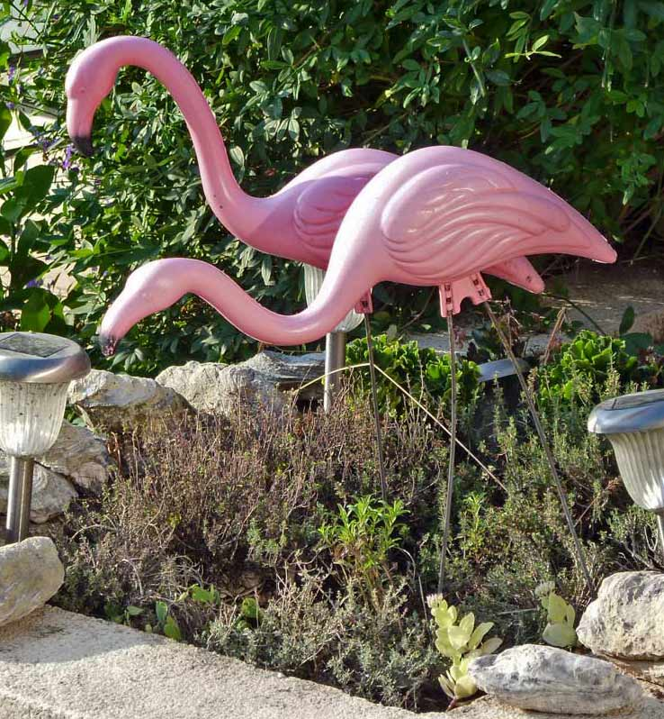
Our brief but intense three days of activities began Wednesday evening, the 28th as guests from other French clubs, FAWCO speakers and AWG club members began to converge at La Bergerie in Poussan, the home of Linda Laval (AWG-LR), FAWCO Region 3 Coordinator. Many of us were old acquaintances and friends since we have been meeting, at least annually, at FAWCO conferences and, from time to time, at various other FAWCO regionals and inter-club events. For others, it was their first exposure to FAWCO’s representatives and FAWCO supporters from other clubs, and it may have seemed strange to see how close the bond has become among those of us who are “FAWCO Friends.” Linda organized a wonder aperitif for us followed by an excellent buffet dinner composed of regional dishes and arranged it so that FAWCO newbies had a chance to become acquainted with the old-timers, and the old-timers had a chance to share personal, club and FAWCO news. In spite of the fact that everyone would have liked to see the party continue, we were all mindful of the fact that tomorrow was another day, and in one capacity or another, we all had work to do starting first thing in the morning.
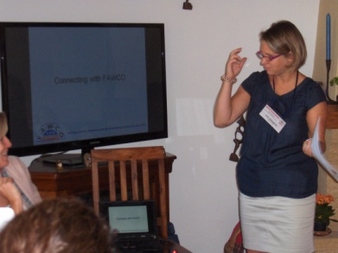
Bright and early Thursday morning, Kim Mousseron, AWG-LR’s president, opened the meetings by welcoming Clydette de Groot, the FAWCO Rep from AWG Paris; Wendy Leyland, President, Sallie Chaballier, FAWCO Rep and Nan de Laubadère, Recording Secretary from AAWE Paris and our three FAWCO speakers as well as all the members of our local AWG who came to support our club and FAWCO and to listen and learn.

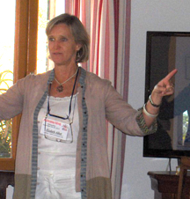
Kim then introduced our first speaker, Elizabeth Abbot (AWA Rome), FAWCO 2nd Vice President for Member Clubs. Elizabeth gave a presentation explaining the value of FAWCO membership not only to Americans living abroad, but also to all club members regardless of nationality, all of whom can benefit as individuals, club members, within their communities and internationally through FAWCO’s alliance with the United Nations and support for the UN Millennium Goals. She explained how the FAWCO committees and task forces function and how an array of small groups, each concentrating on a particular issue can provide detailed and current information on a particular subject. FAWCO has recognized that that the information culture that has grown up around the Internet has led to informational overload on one hand, and the necessity of endless research to keep abreast of current issues on the other. The Committees and Task Forces help to channel this information by collecting and collating it for us so we can tap into just those topics in which we are particularly interested. She also stressed the importance of networking between clubs, and she is currently encouraging all the clubs to contribute to create a “best practices” resource where clubs can share tips, techniques and procedures that have been effective. An additional networking project is to encourage clubs to help each other by connecting clubs with similar issues so they can share ideas and solutions.

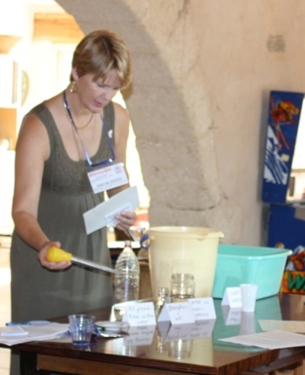
Anne van Oorschot, (AWC the Hague), FAWCO Target Program Chair, was our next speaker and she gave an extremely edifying presentation that highlighted the importance of water worldwide. This included an advertising video, photographs and a practical demonstration of the earth’s actual water composition. There is nothing like an actual demonstration to bring an idea home. Anne arrayed on a table a five-gallon bucket, a 2¼-cup pitcher, 1½ cup and ¼-cup containers representing all earth’s water. With these representing the various quantities of sea, glacier, atmospheric and land water, she used an eyedropper (actually a turkey baster since that was all that was handy) with which she counted out five miniscule drops of water representing all the drinking water on the face of the earth, proportionally speaking. Along with a set of printouts with information on how to promote water awareness within our clubs, Anne handed out little blue ribbons to tie to the faucet in the kitchen to serve as a constant reminder to be constantly aware of the water we are using and to use it wisely.
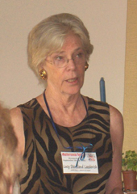
Our final guest speaker, Lucy Stensland Laederich (AAWE Paris), FAWCO US Liaison, proceeded to bring all AWG’s U.S. persons (citizens or residents of the US) up to date on the latest tax initiatives that have just come into effect or will be doing so in the near future. The salient points are that all Americans need to file, even if they do not actually owe taxes to the government. Those who have firmly embedded their heads in the sand, believing themselves thus invisible will be denounced by their own European banks that are in turn being pressed against the wall to reveal all their US person clients since they will soon be subject to heavy financial penalties if they do not. Lucy’s recommendation: get up to date with your filing; tell the truth; and, most important…remember that the government is not out to get American citizens living abroad, but those who practice illegal financial transactions and money laundering.
All three speakers stressed the importance of registering on the FAWCO site in order to have access to FAWCO’s rich library of targeted newsletters and bulletins. Elizabeth will be publishing her monthly “News in Brief” newsletter and additional information as it arises relative to clubs connecting with FAWCO and clubs connecting with other clubs. Anne will be preparing regular Target Program updates on the status of fundraising for the ideas for fundraising, raising awareness…on not only water but also other environmental issues. Finally, Lucy promised to continue to send out bulletins and post all information regarding US issues on the website just as she has so faithfully done in the past. Therefore, the message to our members continues to be…Register on the FAWCO site and sign up for bulletins on those subjects that interest you.
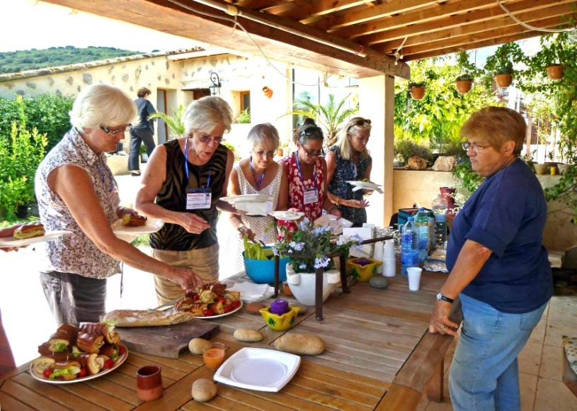
After a light lunch by the pool prepared by AWG-LR’s own talented caterer, Marie Waked, attendees left for a sunny afternoon in Sète, the “little Venice of the Languedoc-Roussillon,” where they visited the marine cemetery, toured the Paul Valéry museum, enjoyed beautiful views and learned the history of this intriguing city conducted by Sète resident and AWG-LR club member Karen Dezeuze.
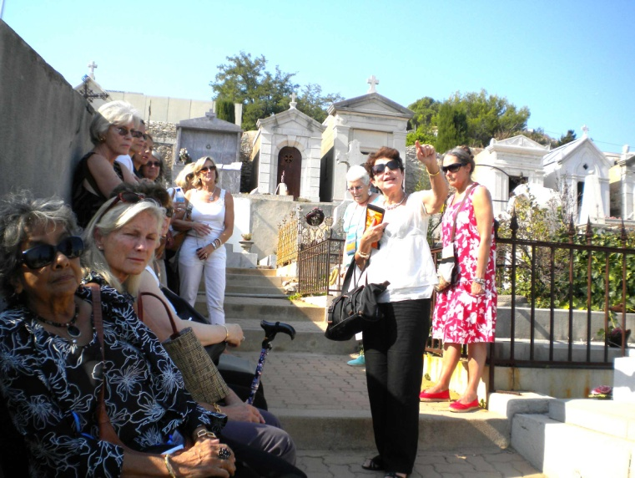
Thursday night a group of 20, composed of AWG members, our three speakers and guests from AWG Paris and AAWE Paris rendezvoused in Mèze for dinner in a cozy restaurant right on the quay overlooking a small port filled with pleasure and fishing boats. Unusual for late September, the evening was balmy, the sky clear, and it was difficult to believe that just days before we had crossed the threshold between summer and autumn, which only enhanced further an already marvelous evening of Mediterranean Magic.
Friday morning, our out of town guests enjoyed two distinct programs, depending on their location. Those in Poussan enjoyed a boat tour into the Mediterranean from Frontignan to visit Sète in Linda and Christophe Laval’s boat, while those who were staying in Montpellier met up at the Comédie with Jan Caire and Kim Mousseron for a walking tour of the Fabre Museum and the old center of Montpellier. Then Friday night, a small party composed of the last remaining guest, Elizabeth Abbot from Rome, went to dinner at the Brasserie du Théatre in downtown Montpellier with Hans and Genette Eysselinck, Jan Caire and Peggy Rigaud. Mother Nature treated us to another balmy evening sitting on the restaurant’s terrace just off the Comédie…the final touch to a successful event!
