

The FAWCO FOUNDATION
Invites you to sail with MSC
(Mediterranean Shipping Company) aboard
* Orchestra *
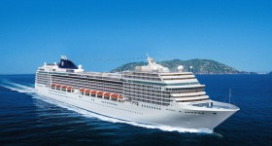
We invite you to sail the beautiful Mediterranean Sea where you will be inspired with an unforgettable holiday and help raise funds for the FAWCO Target Water Project-Tabitha, Cambodia Wells for Clean Water

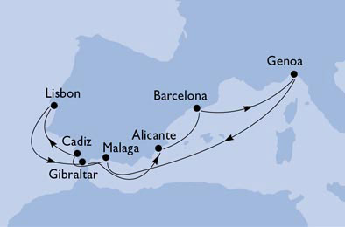
Spain, Portugal, Gibraltar
9 Days - 8 Nights
Departure: Genoa – 29 September 2011
Arrival: Genoa - 7 October 2011
Itinerary
At sea, Malaga, Cadìz; Lisbon, Gibraltar, Alicante, Barcelona

PRICES & DETAILS ARE PER PERSON – DOUBLE OCCUPANCY:
- Double inside cabin minimum Cat. 2 Euro 788 (99€ / day)
- Double; ocean view cabin minimum Cat. 4 Euro 888 (111€ / day)
- Double: ocean view/balcony minimum Cat 7 Euro 988 (123€ / day)
- Surcharge X double used as single + 80%
- Child (under the age of 18 in the same cabin with 2 paying adults) pay only government port taxes, insurance & beverage forfeit Euro 199
PRICES LISTED INCLUDE:
- Accommodations in the cabin of your choice, port taxes
- Cancellation, medical & baggage insurance for EU residents only
- Beverage forfeit (lunch & dinner, at the buffet or in the main dinning room, unlimited quantity of mineral water, soft drinks, beer, white & red D.O.C. wines)
- All meals, breakfast in your cabin, afternoon tea, midnight buffet, snacks
- Captain’s Welcome Cocktail, Gala dinner with it’s special menu
- Private FAWCO Foundation Cocktail with mini silent auction & surprises
- Irish Quilting magazine founder Sherry Nugent conducting workshops & providing materials www.irishquilting.ie
- Use of all amenities on board, swimming pools, deck chairs & towels, whirlpools, gym, library, jogging runway , disco, theater, casino etc
- Transport of baggage during the entire cruise & transport where a tender boat may be necessary
- MINI CLUB for children 3-17 yrs. of age

WHAT IS NOT INCLUDED:
- Beverages at the bar & beverages not included in our forfeit in the dinning room
- Items of a personal nature for which there is a very reasonable charge.
- Gratuities, shore excursions, telephone calls, faxes, internet access, spa treatments & sauna, photographs, laundry service *extra fuel surcharge due to government regulations/taxes Additional fuel surcharges if required
- DONATION to The FOUNDATION: Adults Euro 50 Children Euro 20
- DEADLINE for booking April 22, 2011

FAWCO Foundation VP of Fundraising, Ann De Simoni, will assist with hotel bookings and transfers for those arriving from out of the country the day before departure.

A drawing will be held for the first 30 passengers to book arriving from other countries for a free B&B and transfer from airport or train station for the night of September 28th.

Day | Date | Port | Arrival | Departure
1 | Thurs 29 Sept | Genoa | .... | 18:00
2 | Fri 30 Sept | At sea | .... | ....
3 | Sat 01 Oct | Malaga | 13:00 | 21:00
4 | Sun 02 Oct | Cadiz | 08:00 | 17:00
5 | Mon 03 Oct | Lisbon | 09:00 | 18:00
6 | Tues 04 Oct | Gibraltar | 14:30 | 19:00
7 | Wed 05 Oct | Alicante | 13:00 | 18:00
8 | Thurs 06 Oct | Barcelona | 08:00 | 13:00
9 | Fri 07 Oct | Genoa | 09:00 | ....

The Foundation would like to invite all quilters to join us on this cruise. We had requests for a quilting cruise and we have worked very hard to make that request possible. If you would like to join our sponsor Sherry in the workshops she has prepared you, you can help make a surprise quilted craft item which will be raffled off at the 2012 annual FAWCO conference and proceeds will go 100% to the FAWCO Target Water Project- Tabitha-Wells for Clean Water.

Sherry Nugent Founder and Editor of Irish Quilting magazine is professionally trained in journalism and technical writing, Sherry is passionately devoted to quilting. Merging both, quilting and writing, this editor brings a fresh and new approach to quilting. A native Californian, Sherry lives in County Wicklow with her Irish husband and two daughters.
The Foundation would like to thank her for her sponsorship for conducting the on board quilting workshops and for providing the materials.

Bookings or questions, please contact :
Ann De Simoni
VP FUNDRAISING
e-mail vivadesi@libero.it
cell: +39 333 854 0722
home phone +39 010 32 25 59

We look forward to welcoming you on board!

